[](https://ok.ru/dk?cmd=PopLayerPhoto&st.layer.cmd=PopLayerPhotoOuter&st.layer.type=GROUP&st.layer.revNav=off&st.layer.limitedUi=false&st.layer.sphotoIds=836938868334%3B836938868078%3B836938867822%3B836938867566%3B836938867310%3B836938867054%3B836938866798%3B836938866542%3B836938866286%3B836938866030%3B836938865774&st.layer.showNav=on&st.layer.photoAlbumId=52248882643054&st.layer.epm=off&st.layer.photoId=836938868334&st.layer.opl=off&st.layer.navStartPhotoId=836938868334&st.layer.sbd=off&st.cmd=userMain&st.openPanel=feed&st._aid=GroupTopicLayer_openPhotoLayer)

[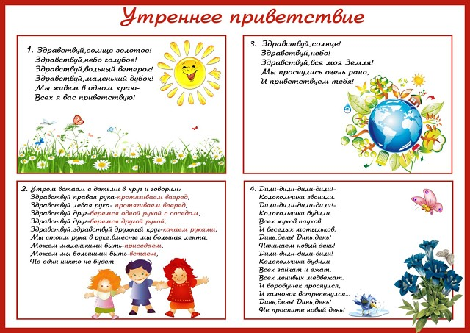](https://ok.ru/dk?cmd=PopLayerPhoto&st.layer.cmd=PopLayerPhotoOuter&st.layer.type=GROUP&st.layer.revNav=off&st.layer.limitedUi=false&st.layer.sphotoIds=836938868334%3B836938868078%3B836938867822%3B836938867566%3B836938867310%3B836938867054%3B836938866798%3B836938866542%3B836938866286%3B836938866030%3B836938865774&st.layer.showNav=on&st.layer.photoAlbumId=52248882643054&st.layer.epm=off&st.layer.photoId=836938868078&st.layer.opl=off&st.layer.navStartPhotoId=836938868078&st.layer.sbd=off&st.cmd=userMain&st.openPanel=feed&st._aid=GroupTopicLayer_openPhotoLayer)

[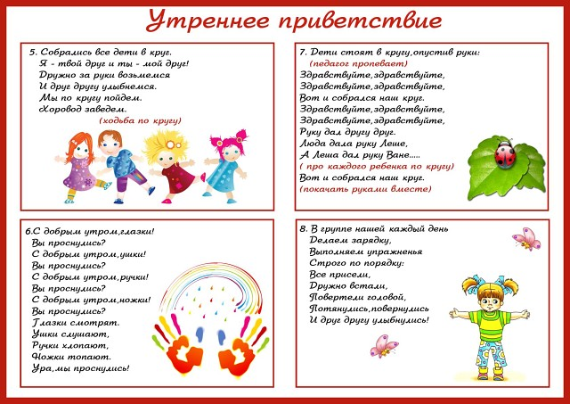](https://ok.ru/dk?cmd=PopLayerPhoto&st.layer.cmd=PopLayerPhotoOuter&st.layer.type=GROUP&st.layer.revNav=off&st.layer.limitedUi=false&st.layer.sphotoIds=836938868334%3B836938868078%3B836938867822%3B836938867566%3B836938867310%3B836938867054%3B836938866798%3B836938866542%3B836938866286%3B836938866030%3B836938865774&st.layer.showNav=on&st.layer.photoAlbumId=52248882643054&st.layer.epm=off&st.layer.photoId=836938867822&st.layer.opl=off&st.layer.navStartPhotoId=836938867822&st.layer.sbd=off&st.cmd=userMain&st.openPanel=feed&st._aid=GroupTopicLayer_openPhotoLayer)

[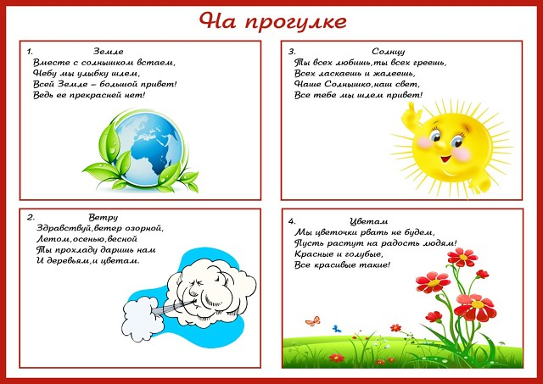](https://ok.ru/dk?cmd=PopLayerPhoto&st.layer.cmd=PopLayerPhotoOuter&st.layer.type=GROUP&st.layer.revNav=off&st.layer.limitedUi=false&st.layer.sphotoIds=836938868334%3B836938868078%3B836938867822%3B836938867566%3B836938867310%3B836938867054%3B836938866798%3B836938866542%3B836938866286%3B836938866030%3B836938865774&st.layer.showNav=on&st.layer.photoAlbumId=52248882643054&st.layer.epm=off&st.layer.photoId=836938867566&st.layer.opl=off&st.layer.navStartPhotoId=836938867566&st.layer.sbd=off&st.cmd=userMain&st.openPanel=feed&st._aid=GroupTopicLayer_openPhotoLayer)

[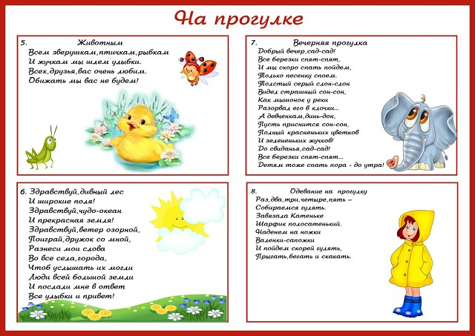](https://ok.ru/dk?cmd=PopLayerPhoto&st.layer.cmd=PopLayerPhotoOuter&st.layer.type=GROUP&st.layer.revNav=off&st.layer.limitedUi=false&st.layer.sphotoIds=836938868334%3B836938868078%3B836938867822%3B836938867566%3B836938867310%3B836938867054%3B836938866798%3B836938866542%3B836938866286%3B836938866030%3B836938865774&st.layer.showNav=on&st.layer.photoAlbumId=52248882643054&st.layer.epm=off&st.layer.photoId=836938867310&st.layer.opl=off&st.layer.navStartPhotoId=836938867310&st.layer.sbd=off&st.cmd=userMain&st.openPanel=feed&st._aid=GroupTopicLayer_openPhotoLayer)

[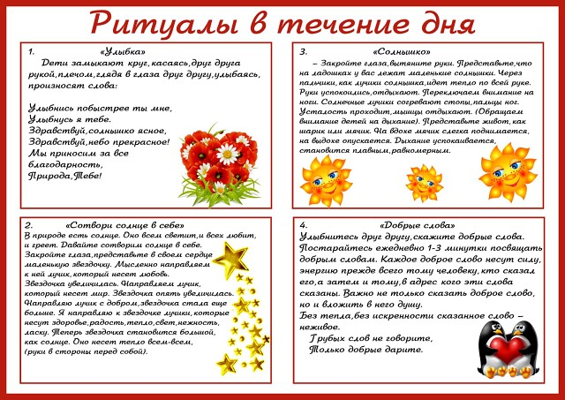](https://ok.ru/dk?cmd=PopLayerPhoto&st.layer.cmd=PopLayerPhotoOuter&st.layer.type=GROUP&st.layer.revNav=off&st.layer.limitedUi=false&st.layer.sphotoIds=836938868334%3B836938868078%3B836938867822%3B836938867566%3B836938867310%3B836938867054%3B836938866798%3B836938866542%3B836938866286%3B836938866030%3B836938865774&st.layer.showNav=on&st.layer.photoAlbumId=52248882643054&st.layer.epm=off&st.layer.photoId=836938867054&st.layer.opl=off&st.layer.navStartPhotoId=836938867054&st.layer.sbd=off&st.cmd=userMain&st.openPanel=feed&st._aid=GroupTopicLayer_openPhotoLayer)

[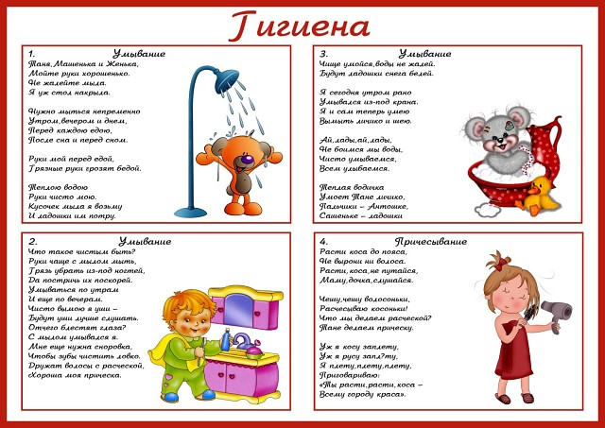](https://ok.ru/dk?cmd=PopLayerPhoto&st.layer.cmd=PopLayerPhotoOuter&st.layer.type=GROUP&st.layer.revNav=off&st.layer.limitedUi=false&st.layer.sphotoIds=836938868334%3B836938868078%3B836938867822%3B836938867566%3B836938867310%3B836938867054%3B836938866798%3B836938866542%3B836938866286%3B836938866030%3B836938865774&st.layer.showNav=on&st.layer.photoAlbumId=52248882643054&st.layer.epm=off&st.layer.photoId=836938866798&st.layer.opl=off&st.layer.navStartPhotoId=836938866798&st.layer.sbd=off&st.cmd=userMain&st.openPanel=feed&st._aid=GroupTopicLayer_openPhotoLayer)

[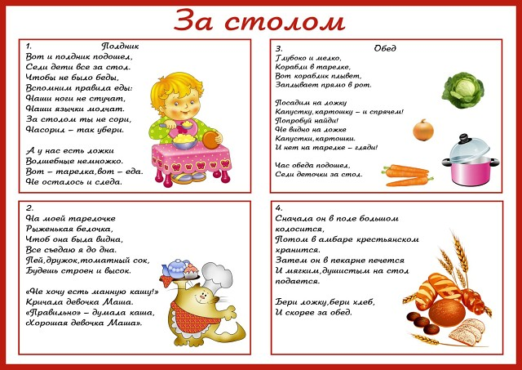](https://ok.ru/dk?cmd=PopLayerPhoto&st.layer.cmd=PopLayerPhotoOuter&st.layer.type=GROUP&st.layer.revNav=off&st.layer.limitedUi=false&st.layer.sphotoIds=836938868334%3B836938868078%3B836938867822%3B836938867566%3B836938867310%3B836938867054%3B836938866798%3B836938866542%3B836938866286%3B836938866030%3B836938865774&st.layer.showNav=on&st.layer.photoAlbumId=52248882643054&st.layer.epm=off&st.layer.photoId=836938866542&st.layer.opl=off&st.layer.navStartPhotoId=836938866542&st.layer.sbd=off&st.cmd=userMain&st.openPanel=feed&st._aid=GroupTopicLayer_openPhotoLayer)

[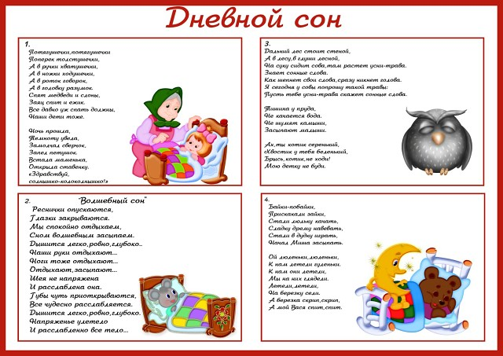](https://ok.ru/dk?cmd=PopLayerPhoto&st.layer.cmd=PopLayerPhotoOuter&st.layer.type=GROUP&st.layer.revNav=off&st.layer.limitedUi=false&st.layer.sphotoIds=836938868334%3B836938868078%3B836938867822%3B836938867566%3B836938867310%3B836938867054%3B836938866798%3B836938866542%3B836938866286%3B836938866030%3B836938865774&st.layer.showNav=on&st.layer.photoAlbumId=52248882643054&st.layer.epm=off&st.layer.photoId=836938866286&st.layer.opl=off&st.layer.navStartPhotoId=836938866286&st.layer.sbd=off&st.cmd=userMain&st.openPanel=feed&st._aid=GroupTopicLayer_openPhotoLayer)

[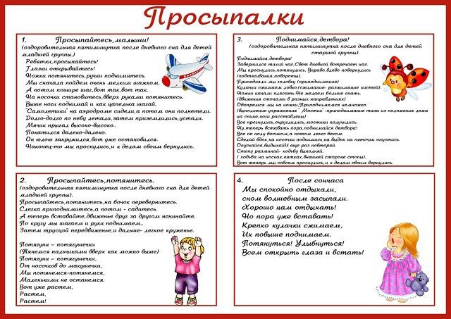](https://ok.ru/dk?cmd=PopLayerPhoto&st.layer.cmd=PopLayerPhotoOuter&st.layer.type=GROUP&st.layer.revNav=off&st.layer.limitedUi=false&st.layer.sphotoIds=836938868334%3B836938868078%3B836938867822%3B836938867566%3B836938867310%3B836938867054%3B836938866798%3B836938866542%3B836938866286%3B836938866030%3B836938865774&st.layer.showNav=on&st.layer.photoAlbumId=52248882643054&st.layer.epm=off&st.layer.photoId=836938866030&st.layer.opl=off&st.layer.navStartPhotoId=836938866030&st.layer.sbd=off&st.cmd=userMain&st.openPanel=feed&st._aid=GroupTopicLayer_openPhotoLayer)

[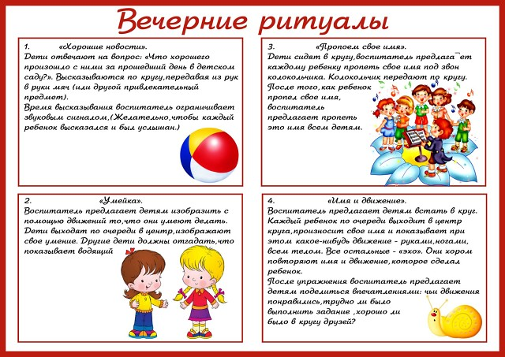](https://ok.ru/dk?cmd=PopLayerPhoto&st.layer.cmd=PopLayerPhotoOuter&st.layer.type=GROUP&st.layer.revNav=off&st.layer.limitedUi=false&st.layer.sphotoIds=836938868334%3B836938868078%3B836938867822%3B836938867566%3B836938867310%3B836938867054%3B836938866798%3B836938866542%3B836938866286%3B836938866030%3B836938865774&st.layer.showNav=on&st.layer.photoAlbumId=52248882643054&st.layer.epm=off&st.layer.photoId=836938865774&st.layer.opl=off&st.layer.navStartPhotoId=836938865774&st.layer.sbd=off&st.cmd=userMain&st.openPanel=feed&st._aid=GroupTopicLayer_openPhotoLayer)

Источник: <http://my-nevalyashki.ru/index.php/kartoteka-rezhimnykh-momentovhttp://my-nevalyashki.ru/index.php/kartoteka-rezhimnykh-momentov>